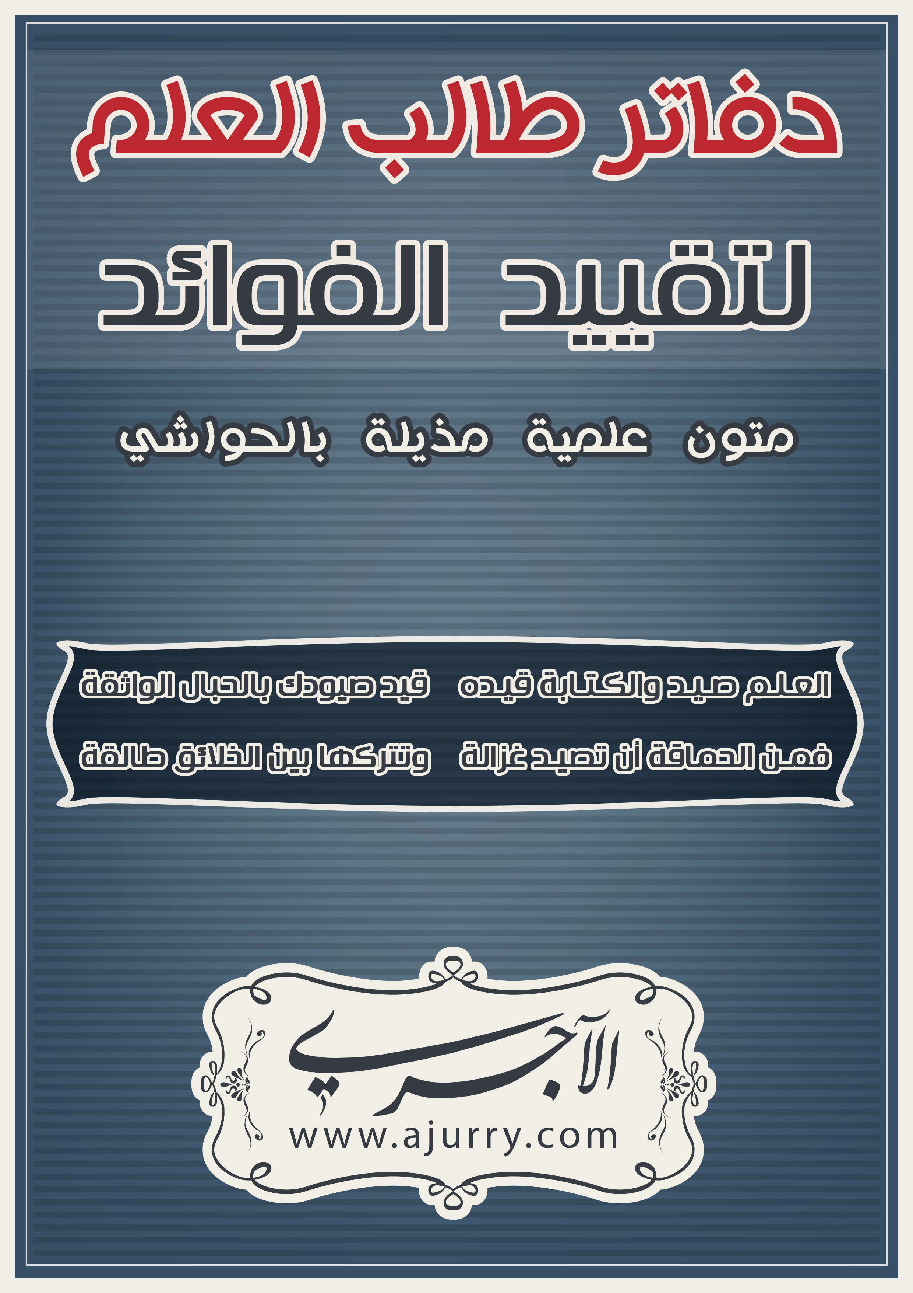
حائية ابن أبي داوود
تَمسَّـكْ بحَـبْلِ اللهِ واتَّبِع الهُـدَى |  | ولا تَـكُ بِدْعِيَّـاً لَعلَّـكَ تُفْلِــحُ
وَدِنْ بِكِتَابِ اللهِ والسُّـنـَنِ التِـي |  | أَتَتْ عَن رَسُولِ اللهِ تَنْجُ وَتَرْبَحُ
ــــــــــــــــــــــــــــــــــــــــــــــــــ............................................................................................................................................................................................................................................................................................................................................................................................................................................................................................................................................................................................................................................................................................................................................................................................................................................................................................................................................................................................................................................................................................................................................................................................................................................................................................................................................................................................................................................................................................................................................................................................................................................................................................................................................................................... .................................................................................................................................................................................................................................... .................................................................................................................................................................................................................................... .................................................................................................................................................................................................................................... .................................................................................................................................................................................................................................... ..................................................................................................................
وَقُـلْ غَيْـرُ مَخْلِوقٍ كَلامُ مَليكِنا |  | بِـذَلكَ دَانَ الأتْقِياءُ وأَفْصحُــوا
وَلا تَكُ فِي القُرْآنِ بالوَقْفِ قَائِــلاً |  | كَمَا قَالَ أتْبَاعٌ لِجَهْمٍ وَأَسْجَحُوا
ولا تَقُـلِ القُرآنُ خَـلقاً قـرأتَـهُ |  | فإنَّ كَـلامَ اللهِ باللفْظِ يُــوضَحُ
ــــــــــــــــــــــــــــــــــــــــــــــــــ ................................................................................................................................................................................................................................................................................................................................................................................................................................................................................................................................................................................................................................................................................................................................................................................................................................................................................................................................................................................................................................................................................................................................................................................................................................................................................................................................................................................................................................................................................................................................................................................................................................................................................................................................................................................................................................................................................................ .................................................................................................................................................................................................................................... .................................................................................................................................................................................................................................... .................................................................................................................................................................................................................................... ....................................................................................................................................................................................................................................
وَقُـلْ يَتَجلَّى اللهُ للخَلْقِ جَـهْـرةً |  | كَمَا البدْرُ لا يَخْفى وَرَبُّكَ أَوْضَـحُ
وَلَيْسَ بمْولُـودٍ وليسَ بِـوَالِــدٍ |  | وَلَيسَ لهُ شِـبْهٌ تَعَالَى المسَبَّـحُ
ــــــــــــــــــــــــــــــــــــــــــــــــــ ................................................................................................................................................................................................................................................................................................................................................................................................................................................................................................................................................................................................................................................................................................................................................................................................................................................................................................................................................................................................................................................................................................................................................................................................................................................................................................................................................................................................................................................................................................................................................................................................................................................................................................................................................................................................................................................................................................ .................................................................................................................................................................................................................................... .................................................................................................................................................................................................................................... .................................................................................................................................................................................................................................... ....................................................................................................................................................................................................................................
وَقَـدْ يُنكِرُ الجَهْميُّ هَــذَا وعِنْدَنَا |  | بِمِصْـدَاقِ ما قُلْنَـا حَدِيثٌ مُصَرِّحُ
رَوَاهُ جَرِيـرٌ عـن مَقَـالِ مُحـمَّدٍ |  | فقُـلْ مِثْلَ ما قَدْ قَالَ في ذَاكَ تَنْجَحُ
ــــــــــــــــــــــــــــــــــــــــــــــــــ.................................................................................................................. ............................................................................................................................................................................................................................................................................................................................................................................................................................................................................................................................................................................................................................................................................................................ .................................................................................................................................................................................................................................................................................................................................................................................................................................................................................................................................................................................................................................................................................................................................................................................................................................................................................................................................................................................................................................................................. .................................................................................................................................................................................................................................... .................................................................................................................................................................................................................................... .................................................................................................................................................................................................................................... .................................................................................................................................................................................................................................... ..................................................................................................................
وَقَـدْ يُنكِـرُ الجَهْمِيُّ أَيضًا يَمِيْنَـهُ |  | وَكِلْتَا يَدَيْـهِ بالفواضِـلِ تَنْفَـحُ
ــــــــــــــــــــــــــــــــــــــــــــــــــ ........................................................................................................................................................................................................................................................................................................................................................................................................................................................................................................................................................................................................................................................................................................... ........................................................................................................................................................................................................................................................................................................................................................................................................................................................................ .................................................................................................................................................................................................................................... .................................................................................................................................................................................................................................... ...................................................................................................................................................................................................................................................................................................................................................... .................................................................................................................................................................................................................................... .................................................................................................................................................................................................................................... .................................................................................................................................................................................................................................... .................................................................................................................................................................................................................................... ..................................................................................................................
وَقُـلْ يَنْـزِلُ الجَبَّارُ فـي كُـلِّ لَيْلَةٍ |  | بِلا كَيْف جَلَّ الواحدُ المتَمَـدِّحُ
إلى طَبَـقِ الدُّنيا يَمُـنُّ بِفَضْلِــهِ |  | فَتُفْـرَجُ أَبْوابُ السَّـماءِ وتُفْتـحُ
ــــــــــــــــــــــــــــــــــــــــــــــــــ ................................................................................................................................................................................................................................................................................................................................................................................................................................................................................................................................................................................................................................................................................................................................................................................................................................................................................................................................................................................................................................................................................................................................................................................................................................................................................................................................................................................................................................................................................................................................................................................................................................................................................................................................................................................................................................................................................................ .................................................................................................................................................................................................................................... .................................................................................................................................................................................................................................... .................................................................................................................................................................................................................................... ....................................................................................................................................................................................................................................
يَقولُ : ألا مُسْـتغفِـرٌ يَلْـقَ غَافِـرًا |  | ومُسْـتَمنِحٌ خَـيْرًا ورِزقًا فأمْنَـحُ
رَوَى ذَاكَ قَـومٌ لا يُـرَدُّ حَــدِيثَهم |  | ألا خَابَ قَــوْمٌ كذَّبـوهُم وقُبِّحُوا
ــــــــــــــــــــــــــــــــــــــــــــــــــ
............................................................................................................................................................................................................................................................................................................................................................................................................................................................................................................................................................................................................................................................................................................ .................................................................................................................................................................................................................................... .................................................................................................................................................................................................................................... .................................................................................................................................................................................................................................... .................................................................................................................................................................................................................................... .................................................................................................................................................................................................................................... .................................................................................................................................................................................................................................... .................................................................................................................................................................................................................................... .................................................................................................................................................................................................................................... ....................................................................................................................................................................................................................................
وَقُـلْ إنَّ خَيْرَ النَّاسِ بَعْـدَ مُحَمَّـدٍ |  | وَزِيـراهُ قُدْمًا , ثُمَّ عُثْمَانُ أرْجَـحُ
وَرابِعُهُـم خَـيْرُ البريَّـةِ بَعْـدَهُـم |  | عَلِـيٌّ حَليفُ الخَـيرِ , بالخَيرِ مُنْجِحُ
وإنَّهمُ و الرَّهْطُ لا رَيْــبَ فِيْهِــمُ |  | عَلَى نُجُبِ الفِرْدَوْسِ في الخُلْدِ تَسْرَحُ
ــــــــــــــــــــــــــــــــــــــــــــــــــ.................................................................................................................................................................................................................................... .................................................................................................................................................................................................................................... .................................................................................................................................................................................................................................... .................................................................................................................................................................................................................................... .................................................................................................................................................................................................................................... .................................................................................................................................................................................................................................... .................................................................................................................................................................................................................................... .................................................................................................................................................................................................................................... .................................................................................................................................................................................................................................... .................................................................................................................................................................................................................................... .................................................................................................................................................................................................................................... ....................................................................................................................................................................................................................................
سَعِيدٌ وسَعْـدٌ وابنُ عَـوْفٍ وطَلْحـةٌ |  | وعَامِرُ فِهْــرٍ والزُّبَيْـرُ المُمَـدَّحُ
وَعَائِشُ أُمِّ الْمُؤْمِنِينَ وَخَالُنا |  | مُعَاوِيَة أَكْرِمْ بِهِ فَهْوَ مُصلحُ
وَأَنْصارُه وَالهَاجِرونَ دِيارَهم |  | بنصرهُمُ عَنْ ظلمةِ النَّارِ زحزحُوا
ــــــــــــــــــــــــــــــــــــــــــــــــــ.................................................................................................................................................................................................................................... .................................................................................................................................................................................................................................... .................................................................................................................................................................................................................................... .................................................................................................................................................................................................................................... .................................................................................................................................................................................................................................... .................................................................................................................................................................................................................................... .................................................................................................................................................................................................................................... .................................................................................................................................................................................................................................... .................................................................................................................................................................................................................................... .................................................................................................................................................................................................................................... .................................................................................................................................................................................................................................... ....................................................................................................................................................................................................................................
وَمَنْ بعدَهُم وَالتابِعُون بِحُسنِ مَا |  | حَذو حَذوهم قَولاً وَفِعلاً فَأفْلحوا
وَقُلْ خَـيْرَ قولٍ في الصَّحَابةِ كُلِّهِـمْ |  | ولا تَــكُ طَعَّاناً تَعِيْـبُ وَتَجْـرَحُ
فَقَدْ نَطَقَ الوَحْيُ المُبينُ بِفَضْلِهِــمْ |  | وفي الفَتْحِ آيٌ في الصَّحابةِ تَمْدَحُ
ـــــــــــــــــــــــــــــــــــــــــــــ.................................................................................................................................................................................................................................... .................................................................................................................................................................................................................................... .................................................................................................................................................................................................................................... .................................................................................................................................................................................................................................... .................................................................................................................................................................................................................................... .................................................................................................................................................................................................................................... .................................................................................................................................................................................................................................... .................................................................................................................................................................................................................................... .................................................................................................................................................................................................................................... .................................................................................................................................................................................................................................... .................................................................................................................................................................................................................................... ....................................................................................................................................................................................................................................
وبِالقَـدَرِ المقْـدُورِ أيْقِنْ فإنَّهُ |  | دِعَامَةُ عقْدِ الدِّينِ والدِّينُ أفْيَـحُ
وَلا تُنْكِرَنْ جَهلاً نَكِيرًا ومُنْكَــراً |  | وَلا الحْوضَ والِميزانَ إنَّـكَ تُنْصَـحُ
ـــــــــــــــــــــــــــــــــــــــــــــ.................................................................................................................................................................................................................................... .................................................................................................................................................................................................................................... .................................................................................................................................................................................................................................... .................................................................................................................................................................................................................................... .................................................................................................................................................................................................................................... .................................................................................................................................................................................................................................... .................................................................................................................................................................................................................................... .................................................................................................................................................................................................................................... .................................................................................................................................................................................................................................... .................................................................................................................................................................................................................................... .................................................................................................................................................................................................................................... .................................................................................................................................................................................................................................... ..................................................................................................................
وقُـلْ يُخْـرِجُ اللهُ العَظيمُ بِفَضلِـهِ |  | مِن النارِ أجْسادًا مِن الفَحْمِ تُطْرَحُ
عَلَى النَّهرِ في الفِردوسِ تَحْيا بِمَائِهِ |  | كَحَبِّ حَميلِ السَّيْلِ إذْ جَاءَ يَطْفَـحُ
ـــــــــــــــــــــــــــــــــــــــــــــ................................................................................................................................................................................................................................... .................................................................................................................................................................................................................................... .................................................................................................................................................................................................................................... .................................................................................................................................................................................................................................... .................................................................................................................................................................................................................................... .................................................................................................................................................................................................................................... .................................................................................................................................................................................................................................... .................................................................................................................................................................................................................................... .................................................................................................................................................................................................................................... .................................................................................................................................................................................................................................... .................................................................................................................................................................................................................................... .................................................................................................................................................................................................................................... ..................................................................................................................
فإنَّ رَسُـولَ اللـهِ للخَلـقِ شَافـعٌ |  | وقُلْ فِي عَذابِ القَبرِ حـقٌّ مُوَضَّحُ
ولا تُكْفِّرَنَّ أهْلَ الصَّلاةِ وإِنْ عَصَـوا |  | فكلُّهُمُ يَعْصِي وذُو العَرشِ يَصْفَـحُ
ــــــــــــــــــــــــــــــــــــــــــــ .................................................................................................................................................................................................................................... .................................................................................................................................................................................................................................... .................................................................................................................................................................................................................................... .................................................................................................................................................................................................................................... .................................................................................................................................................................................................................................... .................................................................................................................................................................................................................................... .................................................................................................................................................................................................................................... .................................................................................................................................................................................................................................... .................................................................................................................................................................................................................................... .................................................................................................................................................................................................................................... .................................................................................................................................................................................................................................... ....................................................................................................................................................................................................................................
ولا تَعتقِــدْ رَأيَ الخَوارجِ إنَّـهُ |  | مَقَالٌ لِمَنْ يهـواهُ يُرْدِي ويَفْضَحُ
ولا تَــكُ مُرْجِيـًّا لَعُوبًا بِدِينِـهِ |  | ألا إنَّمَا المُرْجيُّ بالدِّينِ يَمْـزَحُ
ـــــــــــــــــــــــــــــــــــــــــــــ...................................................................................................................................................................................................................................................................................................................................................................................................................................................................................................................................................................................................................................................................................................................................................................................................................................................................................................................................................................................................................................................................................................................................................................................................................................................................................................... .................................................................................................................................................................................................................................... .................................................................................................................................................................................................................................... .................................................................................................................. .................................................................................................................................................................................................................................... .................................................................................................................................................................................................................................... .................................................................................................................................................................................................................................... ....................................................................................................................................................................................................................................
وقُــلْ إنَّما الإيمانُ قـَوْلٌ ونيَّـةٌ |  | وِفعْلٌ عَلَى قَـولِ النبيِّ مُصَرَّحُ
ويَنْقُصُ طَـوْرًا بالمعَاصِي وَتَـارةً |  | بطَاعَتِهِ يَنْمِي وفي الوَزنِ يَرْجَحُ
ـــــــــــــــــــــــــــــــــــــــــــــ.................................................................................................................................................................................................................................... .................................................................................................................................................................................................................................... .................................................................................................................................................................................................................................... .................................................................................................................................................................................................................................... .................................................................................................................................................................................................................................... .................................................................................................................................................................................................................................... .................................................................................................................................................................................................................................... .................................................................................................................................................................................................................................... .................................................................................................................................................................................................................................... .................................................................................................................................................................................................................................... .................................................................................................................................................................................................................................... .................................................................................................................................................................................................................................... ..................................................................................................................
وَدَعْ عنكَ آراءَ الرِّجالِ وَقـولَهُـم |  | فَقْولُ رَسُولِ اللهِ أَزكى وَأَشْــرَحُ
وَلا تَكُ مِـن قـوْمٍ تَلَهَّـوْ بِدِينِهِـم |  | فَتَطْعـنَ في أَهَلِ الحَدَيثِ وتَقْـدَحُ
إذا مَا اعتقـدْتَ الدَّهْرَ يا صَاحِ هذِه |  | فَأَنْـتَ عَلـى خَيْـرٍ تَبِيتُ وتُصْبِحُ
ـــــــــــــــــــــــــــــــــــــــــــــ.................................................................................................................................................................................................................................... .................................................................................................................................................................................................................................... .................................................................................................................................................................................................................................... .................................................................................................................................................................................................................................... .................................................................................................................................................................................................................................... .................................................................................................................................................................................................................................... .................................................................................................................................................................................................................................... .................................................................................................................. .................................................................................................................................................................................................................................... .................................................................................................................................................................................................................................... .................................................................................................................................................................................................................................... ....................................................................................................................................................................................................................................
............................................................................................ والحمد لله رب العالمين.
.................................................................................................................................................................................................................................... .................................................................................................................................................................................................................................... .................................................................................................................. ................................................................................................................................................................................................................................................................................................................................................................................................................................................................................................................................................................................................................................................................................................................................................................................................................................................................................................................................................ .................................................................................................................................................................................................................................... .................................................................................................................. .................................................................................................................................................................................................................................... .................................................................................................................................................................................................................................... .................................................................................................................. .................................................................................................................................................................................................................................... .................................................................................................................................................................................................................................... .................................................................................................................. .................................................................................................................................................................................................................................... .................................................................................................................................................................................................................................... .................................................................................................................. .................................................................................................................................................................................................................................... .................................................................................................................................................................................................................................... .................................................................................................................. .................................................................................................................................................................................................................................... .................................................................................................................................................................................................................................... .................................................................................................................................................................................................................................... .................................................................................................................................................................................................................................... .................................................................................................................................................................................................................................... .................................................................................................................................................................................................................................... .................................................................................................................................................................................................................................... .................................................................................................................................................................................................................................... .................................................................................................................................................................................................................................... .................................................................................................................................................................................................................................... ....................................................................................................................................................................................................................................

