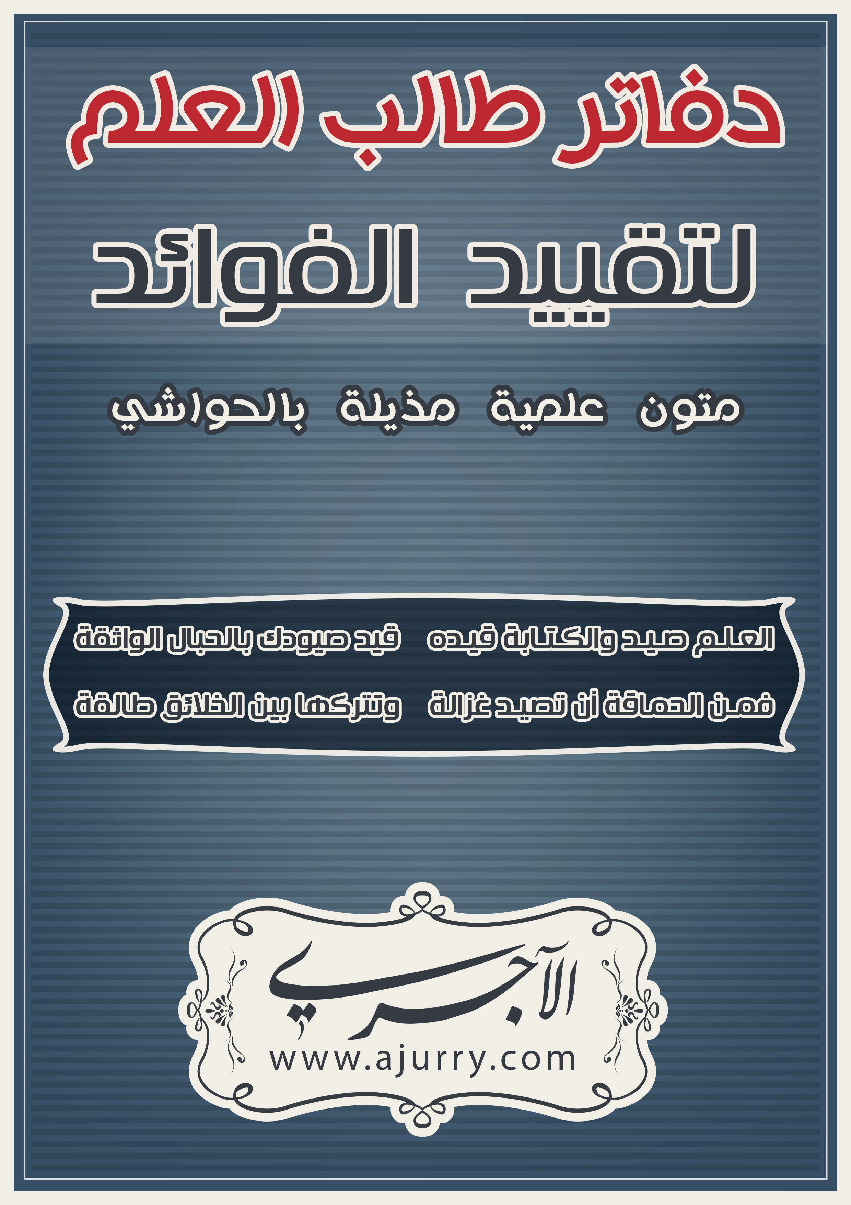
نواقض الإسلام
قال الشيخ محمد بن عبد الوهاب –رحمه الله - :
بِسْمِ اللهِ الرَّحْمَنِ الرَّحِيمِ
اعْلَمْ أَنَّ نَوَاقِضَ الإِسْلَامِ عَشَرَةُ نَوَاقِض :
الأَوَّلُ :
الشِّرْكُ فِي عِبَادَةِ اللهِ، قَالَ تَعَالَى: ﴿ إِنَّ اللَّهَ لاَ يَغْفِرُ أَن يُشْرَكَ بِهِ وَيَغْفِرُ مَا دُونَ ذَلِكَ لِمَن يَشَاء ﴾ [النساء: 48] وَقَالَ تَعَالَى:﴿ إِنَّهُ مَن يُشْرِكْ بِاللَّهِ فَقَدْ حَرَّمَ اللَّهُ عَلَيْهِ الْجَنَّةَ وَمَأْوَاهُ النَّارُ وَمَا لِلظَّالِمِينَ مِنْ أَنصَارٍ ﴾ [المائدة: 72] وَمِنْهُ الذَّبْحُ لِغَيْرِ اللهِ، كَمَنْ يَذْبَحُ لِلْجِنِّ أَوْ لِلْقَبْرِ.
ــــــــــــــــــــــــــــــــــــــــــــــــــ
............................................................................................................................................................................................................................................................................................................................................................................................................................................................................................................................................................................................................................................................................................................................................................................................................................................................................................................................................................................................................................................................................................................................................................................................................................................................................................................................................................................................................................................................................................................................................................................................................................................................
......................................................................................................................................................................................................................................................................................................................................................
الثَّانِي :
مَنْ جَعَلَ بَيْنَهُ وَبَيْنَ اللهِ وَسَائِطَ يَدْعُوهُمْ وَيسْأَلُهُمْ الشَّفَاعَةَ، وَيَتَوَكَّلُ عَلَيْهِمْ كَفَرَ إِجْمَاعًا.
ــــــــــــــــــــــــــــــــــــــــــــــــــ
......................................................................................................................................................................................................................................................................................................................................................................................................................................................................................................................................................................................................................................................................................................................................................................................................................................................................................................................................................................................................................................................................................................................................................................................................................................................................................................
............................................................................................................................................................................................................................................................................................................................................................................................................................................................................................................................................................................................................................................................................................................................................................................................................................................................................................................................................................................................................................................................................................................................................................................................................................................................................................................................................................................................................................................................................................................................................................................................................................................................
الثالث:
مَنْ لَمْ يُكَفِّرْ المُشْرِكِينَ أَوْ شَكَّ فِي كُفْرِهِمْ، أَوْ صَحَّحَ مَذْهَبَهُم، كَفَرَ.
ــــــــــــــــــــــــــــــــــــــــــــــــــ
................................................................................................................................................................................................................................................................................................................................................................................................................................................................................................................................................................................................................................................................................................................................................................................................................................................................................................................................................................................................................................................................................................................................................................................................................................................................................................................................................................................................................................................................................................................................................................................................................................................................................................................................................................................................................................................................................................ .................................................................................................................. ..................................................................................................................
.......................................................................................................................................................................................................................................................................................................................................................................................................................................................................
......................................................................................................................................................................................................................................................................................................................................................
الرابع:
مَنْ اعْتَقَدَ أَنَّ غَيْرَ هَدْي النَّبِيِّ صَلَّى اللهُ عَلَيْهِ وَسَلَم أَكْمَلُ مِنْ هَدْيِهِ وَأَنَّ حُكْمَ غَيْرِهِ أَحْسَنُ مِنْ حُكْمِهِ كَالذِينَ يُفَضِّلُونَ حُكْمَ الطَّوَاغِيتِ عَلَى حُكْمِهِ فَهُوَ كَافِرٌ.
ــــــــــــــــــــــــــــــــــــــــــــــــــ
.................................................................................................................. ............................................................................................................................................................................................................................................................................................................................................................................................................................................................................................................................................................................................................................................................................................................ .............................................................................................................................................................................................................................................................................................................................................................................................................................................................................................................................................................................................................................................................................................................................................................................................................................. ..........................................................................................................................................................................................................................................................................................................................................................................................................................................................................................................................................................................................
..........................................................................................................................................................................................................................................................................................................................................................................................................................................................................................................................................................................................
الخامس:
مَنْ أَبْغَضَ شَيْئًا مِمَّا جَاءَ بِهِ الرَّسُولُ صَلَّى اللهُ عَلَيْهِ وَسَلَم - وَلَوْ عَمِلَ بِهِ -، كَفَرَ.
ــــــــــــــــــــــــــــــــــــــــــــــــــ
............................................................................................................................................................................................................................................................................................................................................................................................................................................................................................................................................................................................................................................................................................................ .................................................................................................................................................................................................................................... .................................................................................................................................................................................................................................... .................................................................................................................................................................................................................................... .................................................................................................................................................................................................................................... ......................................................................................................................................................................................................................................................................................................................................................
...................................................................................................................................................................................................................................................................................................................................................... .................................................................................................................................................................................................................................... ......................................................................................................................................................................................................................................................................................................................................................
السادس:
مَنِ اسْتَهْزَأَ بِشَيْءٍ مِنْ دِينِ الرَّسُولِ صَلَّى اللهُ عَلَيْهِ وَسَلَم، أَوْ ثَوَابَ اللهِ، أَوْ عِقَابِهِ، كَفَرَ، وَالدَلِيلُ قَوْلُهُ تَعَالَى: ﴿ وَلَئِن سَأَلْتَهُمْ لَيَقُولُنَّ إِنَّمَا كُنَّا نَخُوضُ وَنَلْعَبُ قُلْ أَبِاللَّهِ وَآيَاتِهِ وَرَسُولِهِ كُنتُمْ تَسْتَهْزِؤُونَ * لاَ تَعْتَذِرُواْ قَدْ كَفَرْتُم بَعْدَ إِيمَانِكُمْ إِن نَّعْفُ عَن طَائِفَةٍ مِّنكُمْ نُعَذِّبْ طَائِفَةً بِأَنَّهُمْ كَانُواْ مُجْرِمِينَ ﴾ [التوبة: 65، 66] ، وآيةٌ في يونس وهي قوله ‏:‏ ‏(أَلا إِنَّ أَوْلِيَاء اللَّهِ لاَ خَوْفٌ عَلَيْهِمْ وَلاَ هُمْ يَحْزَنُونَ‏)‏ ‏[‏يونس، الآية‏:‏ 62‏]‏، ثم صار الأمر عند أكثر من يدعى .
ــــــــــــــــــــــــــــــــــــــــــــــــــ
.................................................................................................................................................................................................................................................................................................................................................................................................................................................................................................................................................................................................................................................................................................................................................................................................................................................................................................................................................................................................................................................................................................................................................................................................................................................................................................................................................................................................................................................................................................................................................................................................................................................................................................................................................................................................................................................................................................................................................................................................................................................................................................................................... .................................................................................................................................................................................................................................... ..................................................................................................................
السابع:
السِّحْرُ - وَمِنْهُ: الصَّرْفُ وَالعَطْفُ-، فَمَنْ فَعَلَهُ أَوْ رَضِيَ بِهِ كَفَرَ، وَالدَلِيلُ قَوْلُهُ تَعَالَى: ﴿ وَمَا يُعَلِّمَانِ مِنْ أَحَدٍ حَتَّى يَقُولاَ إِنَّمَا نَحْنُ فِتْنَةٌ فَلاَ تَكْفُرْ﴾ [البقرة: 102] .
ــــــــــــــــــــــــــــــــــــــــــــــــــ
............................................................................................................................................................................................................................................................................................................................................................................................................................................................................................................................................................................................................................................................................................................
.................................................................................................................................................................................................................................... .................................................................................................................................................................................................................................... .................................................................................................................................................................................................................................... .................................................................................................................................................................................................................................... .............................................................................................................................................................................................. .................................................................................................................................................................................................................................... .................................................................................................................................................................................................................................... ......................................................................................................................................................................................................................................................................................................................................................
الثَّامِنُ :
مُظَاهَرَةُ المُشْرِكِينَ وَمُعَاوَنَتُهُمْ عَلَى المُسْلِمِينَ وَالدَلِيلُ قَوْلُهُ تَعَالَى: ﴿ وَمَن يَتَوَلَّهُم مِّنكُمْ فَإِنَّهُ مِنْهُمْ إِنَّ اللَّهَ لاَ يَهْدِي الْقَوْمَ الظَّالِمِين﴾ [المائدة: 51]. ــــــــــــــــــــــــــــــــــــــــــــــــــ
.................................................................................................................................................................................................................................... .................................................................................................................................................................................................................................... .................................................................................................................................................................................................................................... .................................................................................................................................................................................................................................... .................................................................................................................................................................................................................................... .................................................................................................................................................................................................................................... .................................................................................................................................................................................................................................... .................................................................................................................................................................................................................................... .................................................................................................................................................................................................................................... .................................................................................................................................................................................................................................... .................................................................................................................................................................................................................................... ....................................................................................................................................................................................................................................
التَّاسِعُ :
مَنْ اعْتَقَدَ أَنَّ بَعْضَ النَّاسِ يَسَعُهُ الخُرُوجُ عَنْ شَرِيعَةِ مُحَمَّدٍ صَلَّى اللهُ عَلَيْهِ وَسَلَم كَمَا وَسِعَ الخَضِرُ الخُرُوجَ عَنْ شَرِيعَةِ مُوسَى عَلَيهِ السَّلَامُ، فَهُوَ كَافِرٌ .
ــــــــــــــــــــــــــــــــــــــــــــــــــ
.................................................................................................................................................................................................................................... .................................................................................................................................................................................................................................... .................................................................................................................................................................................................................................... .................................................................................................................................................................................................................................... .................................................................................................................................................................................................................................... .................................................................................................................................................................................................................................... .................................................................................................................................................................................................................................... .................................................................................................................................................................................................................................... .................................................................................................................................................................................................................................... .................................................................................................................................................................................................................................... .................................................................................................................................................................................................................................... ....................................................................................................................................................................................................................................
العَاشِرُ:
الإِعْرَاضُ عَنْ دِينِ اللهِ تَعَالَى لَا يَتَعَلَّمُـهُ وَلَا يَعْمَـلُ بِهِ، وَالدَلِيلُ قَوْلُهُ تَعَالَى: ﴿ وَمَنْ أَظْلَمُ مِمَّن ذُكِّرَ بِآيَاتِ رَبِّهِ ثُمَّ أَعْرَضَ عَنْهَا إِنَّا مِنَ الْمُجْرِمِينَ مُنتَقِمُونَ ﴾ [السجدة:22]. ـــــــــــــــــــــــــــــــــــــــــــــ
.................................................................................................................................................................................................................................... .................................................................................................................................................................................................................................... .................................................................................................................................................................................................................................... .................................................................................................................................................................................................................................... .................................................................................................................................................................................................................................... .................................................................................................................................................................................................................................... .................................................................................................................................................................................................................................... .................................................................................................................................................................................................................................... .................................................................................................................................................................................................................................... .................................................................................................................................................................................................................................... ........................................................................................................................................................................................................................................................................................................................................................................................................................................................................
وَلَا فَرْقَ فِي جَمِيعِ هَذِهِ النَّوَاقِضِ بَيْنَ الهَازِلِ وَالجَادِّ وَالخَائِفِ إِلَّا المُكْرَهِ.
وَكُلُّهَا مِنْ أَعْظَمِ مَا يَكُونُ خَطَرًا، وَأَكْثَرِ مَا يَكُونُ وُقُوعًا، فَيَنْبَغِي لِلْمُسْلِمِ أَنْ يَحْذَرَهَا وَيَخَافَ مِنْهَا عَلَى نَفْسِهِ.
نَعُوذُ بِاللهِ مِنْ مُوجِبَاتِ غَضَبِهِ، وَأَلِيمِ عِقَابِهِ. وَصَلَّى اللهُ عَلَى خَيْرِ خَلْقِهِ مُحَمَّدٍ، وَعَلَى آلِهِ وَصَحْبِهِ وَسَلَّمَ ـــــــــــــــــــــــــــــــــــــــــــــ
.................................................................................................................................................................................................................................... .................................................................................................................................................................................................................................... .................................................................................................................................................................................................................................... .................................................................................................................................................................................................................................... .................................................................................................................................................................................................................................... .................................................................................................................................................................................................................................... .................................................................................................................................................................................................................................... .................................................................................................................................................................................................................................... .................................................................................................................................................................................................................................... .................................................................................................................. .................................................................................................................. .................................................................................................................. ............................................................................................................................................................................................................. والحمد لله رب العالمين .
.................................................................................................................. .................................................................................................................. .................................................................................................................. .................................................................................................................. .................................................................................................................. .................................................................................................................. .................................................................................................................. .................................................................................................................. .................................................................................................................. .................................................................................................................. .................................................................................................................. .................................................................................................................. .................................................................................................................. .................................................................................................................. .................................................................................................................. .................................................................................................................. .................................................................................................................. .................................................................................................................. .................................................................................................................. .................................................................................................................. .................................................................................................................. .................................................................................................................. .................................................................................................................. .................................................................................................................. .................................................................................................................. .................................................................................................................. .................................................................................................................. .................................................................................................................. .................................................................................................................. .................................................................................................................. .................................................................................................................. .................................................................................................................. .................................................................................................................. .................................................................................................................. .................................................................................................................. .................................................................................................................. .................................................................................................................. .................................................................................................................. .................................................................................................................. .................................................................................................................. .................................................................................................................. .................................................................................................................. .................................................................................................................. .................................................................................................................. .................................................................................................................. .................................................................................................................. .................................................................................................................. .................................................................................................................. .................................................................................................................. .................................................................................................................. .................................................................................................................. .................................................................................................................. .................................................................................................................. .................................................................................................................. .................................................................................................................. .................................................................................................................. .................................................................................................................. ..................................................................................................................

